* Check failed back-ups last three weeks to determine failures that occur more than once in a row

Check if described Monitoring thresholds are sufficient, valid and implemented

1.login to aws portal.

Need to check for all 3 accounts.

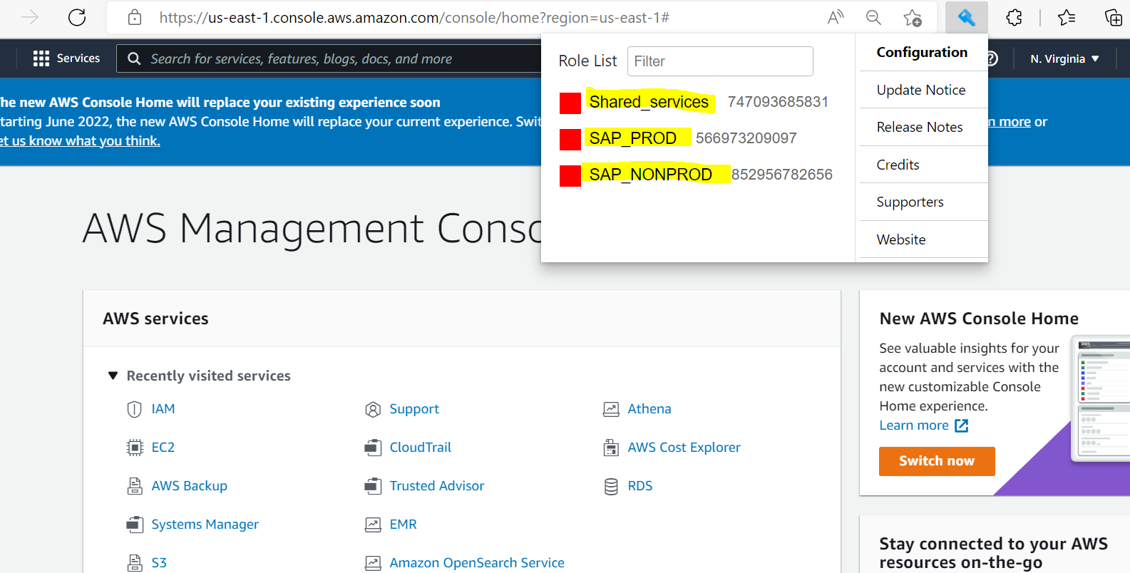

2.search for AWS backup

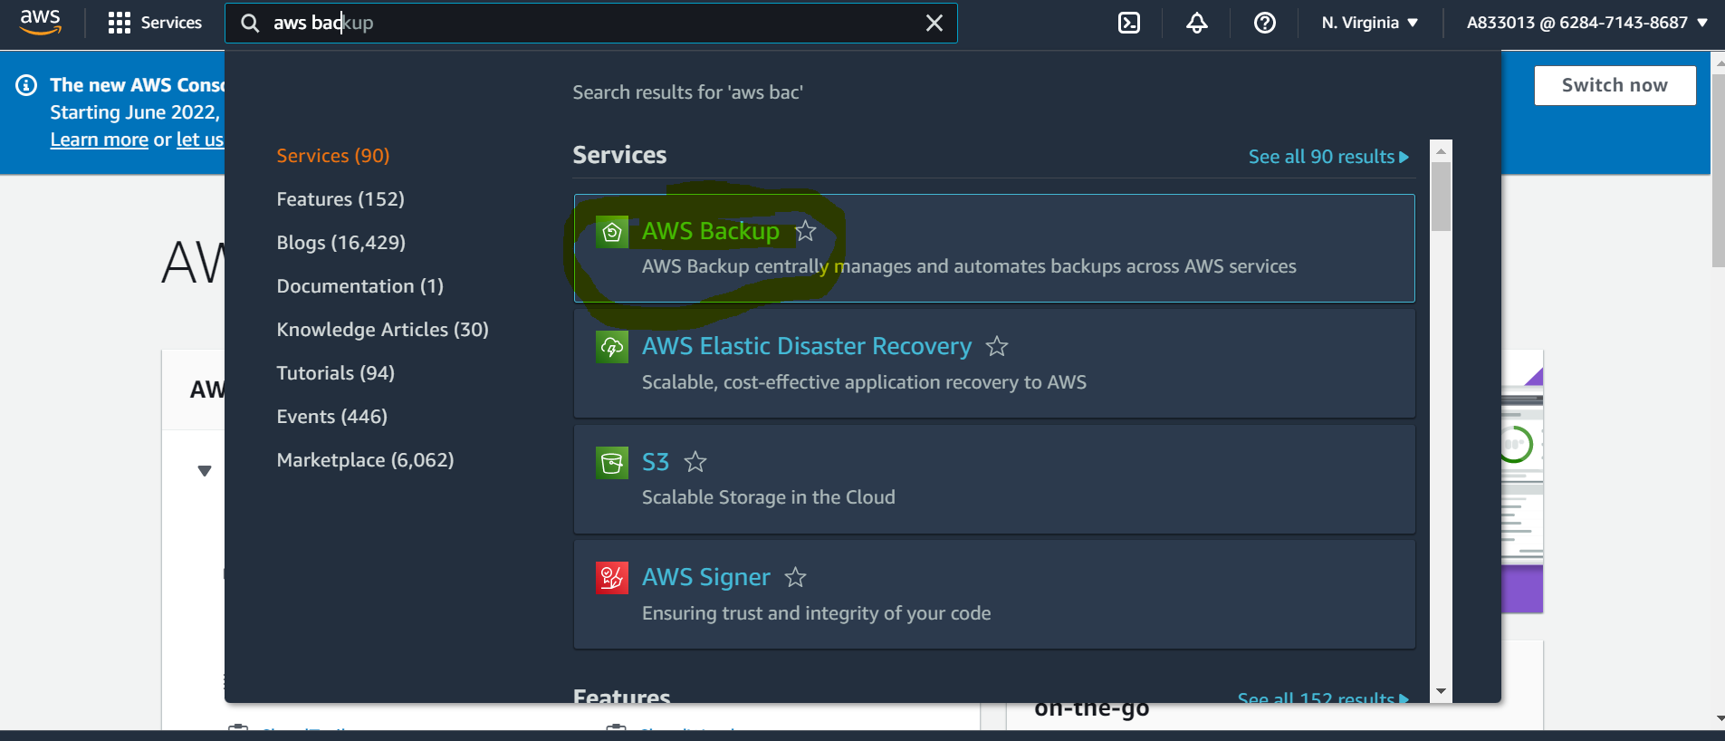

3.go to dashboard

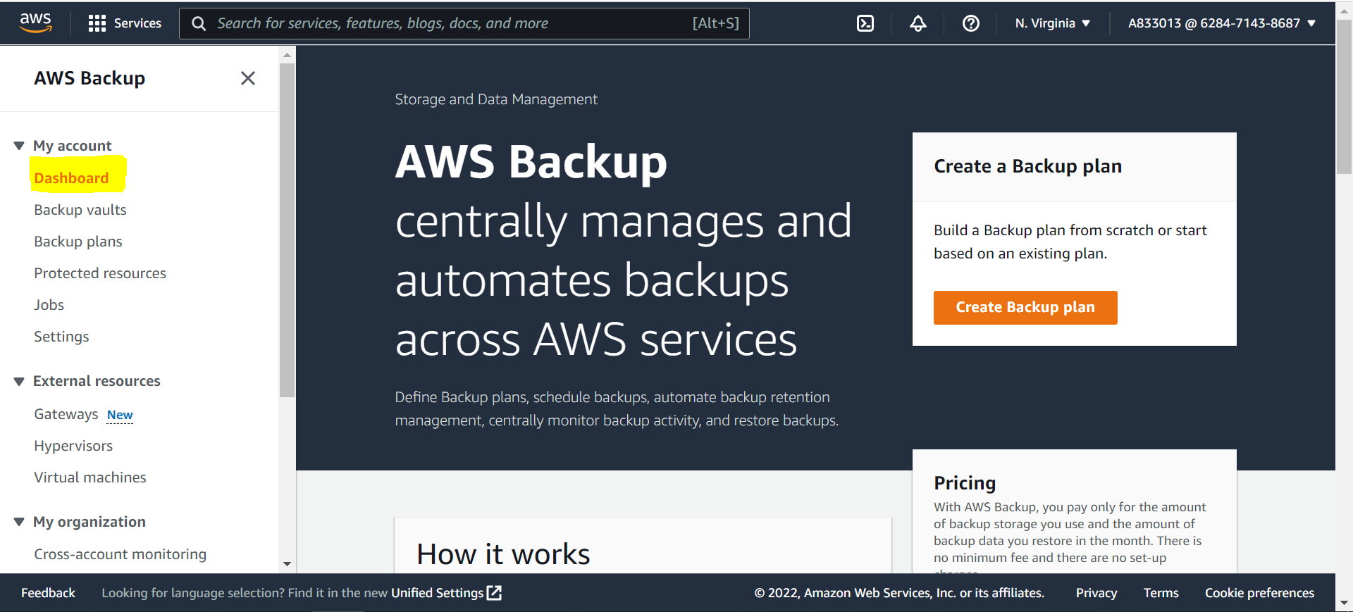

4.here you can see backup status

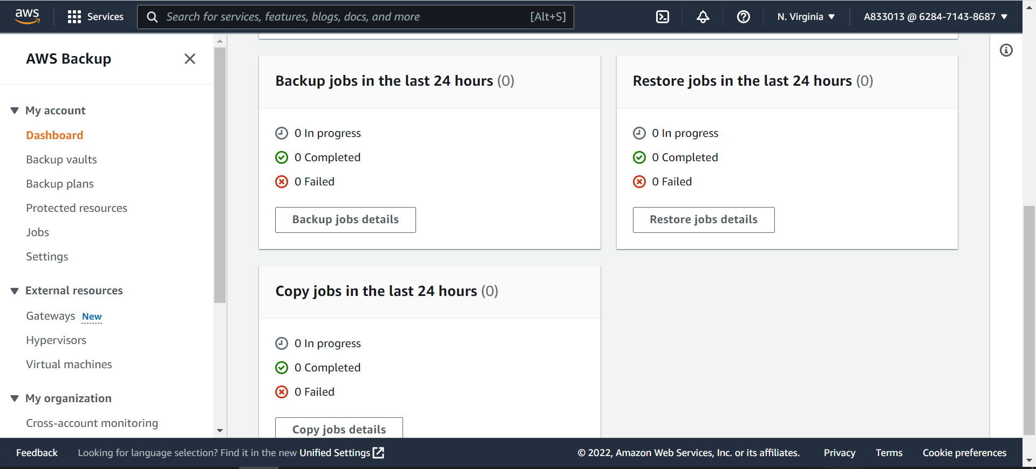

Here you can see backup status Completed and 0 failed. If any backup is failed then need to check.